4 DAYS 3 NIGHTS KUALA LUMPUR + LANGKAWI PACKAGE
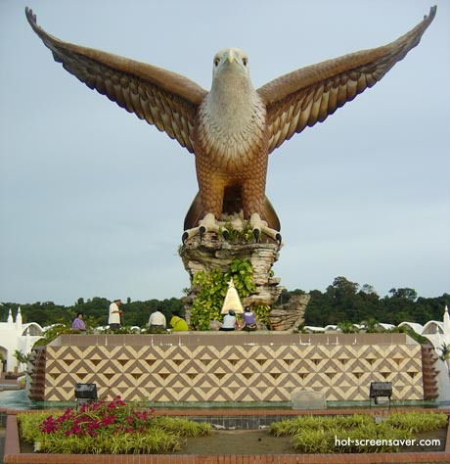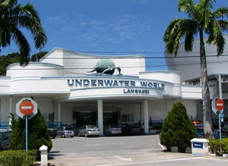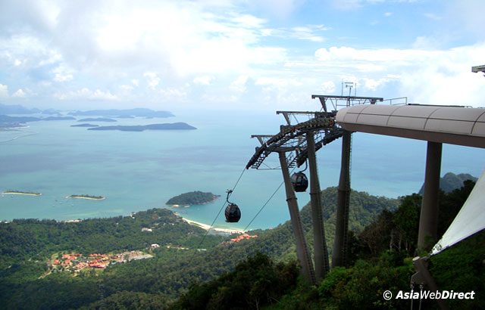

Hotel | Twin / Triple  (per person) | Child with extra bed | Child without bed | Single supplement additional
(3*) Sentral Pudu hotel KUL +  Mutiara Burau Bay LGK | RM 810.00 | RM 650.00 | RM 480.00 | RM 365.00
(4*) Coronade Hotel KUL +  Holiday Villa LGK | RM 1005.00 | RM 795.00 | RM 600.00 | RM 555.00
(5*) Maya Hotel KUL +  Langkawi Lagoon LGK | RM 1075.00 | RM 855.00 | RM 640.00 | RM 630.00

ITINERARY :

Day 1 ARRIVE KUALA LUMPUR
Arrive KUALA LUMPUR airport , transfer to Kuala Lumpur half day City tour – National Monument , Independence Square , National Mosque , King Palace , Petronas Twin Tower ( photo stop) .
After tour , transfer back to hotel , free at own leisure , overnite at Kuala Lumpur hotel .

Day 2 KUALA LUMPUR - LANGKAWI
Brekfast at hotel , arrive Langkawi airport , transfer to hotel for check in . Overnite at Langkawi Hotel .

Day 3 LANGKAWI (BREAKFAST)
Breakfast at hotel, proceed to half day Langkawi Tour - visit Eagle Square, Batik, Mahsuri Memorial Park, Underwater World, after tour transfer back to hotel . Overnite at Langkawi Hotel .

Day 4 LANGKAWI – AIRPORT - DEPARTURE (BREAKFAST)
Breakfast at hotel, free until transfer to Airport for your departure from Langkawi - Kuala Lumpur.

Package Inclusive :
~ Transfer in/out (seat in coach).
~ 3 Nights accommodation (Twin sharing).
~ 3 Hotel Breakfast.
~ Half day Kuala Lumpur & Langkawi tour (seat in coach)

Package EXCLUDED :
~ Personal expenses
~ Domestic Air ticket
~ Tipping
~ Travel Insurance
~ Entrance fees.

REMARKS :
~ Rate is based on minimum 02 paxs and above.
~ Package is based on SIC basic.
~ Rates subject to change without any notice.
~Validity : Until March 2012 .
~ All rate quoted is base on RINGGIT MALAYSIA

PEAK SEASON SURCHARGE :-
~ Sentral Pudu hotel additional surcharge @ RM 50.00 per room per night on 24 – 26 Dec &
31 Dec – 01 Jan 2012.
~ Coronade Hotel additional surcharge @ RM 35.00 per room per night on 01 – 31 Dec 2011 .
~ Coronade Hotel compulsory dinner on Christmas Eve & Day @ RM 100.00 per adult
~ Coronade Hotel compulsory dinner on New Year @ RM 120.00 per adult .
~ Holiday Villa Hotel additional surcharge @ RM 80.00 per room per night fall on 15 Dec 11 – 15 Jan 12 .
~ Holiday Villa Hotel compulsory Christmas eve dinner @ RM 175.00 per adult & RM 95.00 per child.
~ Holiday Villa Hotel compulsory New Year eve dinner @ RM 290.00 per adult & 155.00 per child .
~ Mutiara Burau Bay Hotel additional surcharge @ RM 100.00 per room per night fall on 20 Dec 11 – 14 Jan 12 .
~ Mutiara Burau Bay Hotel compulsory Christmas eve dinner @ RM 200.00 for adult & RM 100.00 for child .
~ Mutiara Buray Bay compulsory New Year Eve dinner @ RM 300.00 for adult & RM 150.00 for child .
~ Langkawi Lagoon Hotel additional surcharge @ RM 80.00 per room per night on 20 Jan – 29 Jan 2012 .
~ Langkawi Lagoon Hotel additional surcharge @ RM 130.00 per room per night on 20 Dec 11 – 10 Jan 12 .
~ Langkawi Lagoon compulsory dinner on 31 Dec @ Rate TBA .
~ Langkawi Lagoon CLOSE OUT DATE : 31 Nov – 13 Dec .

